Chapter 10, Solution 83.

The schematic is shown below. The frequency is

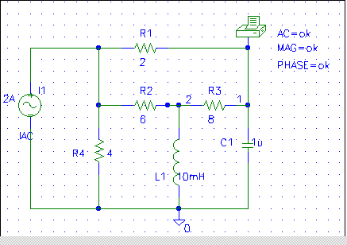

When the circuit is saved and simulated, we obtain from the output file

FREQ VM(1) VP(1)
1.592E+02 6.611E+00 -1.592E+02

Thus,
v_{o} = 6.611cos(1000t – 159.2º) V

